Task-Based Activity: Make a list of items for a first aid kit
Laubach Connection: Laubach Way to Reading (LWR) Book 3, Lesson 7
OALCF Link
Relevant Goal Paths
Apprenticeship, Employment, Independence, Postsecondary, Secondary School Credit
Rationale: Learners on all of the goal paths will need to make lists for a variety of different reasons.

Task-Based Activity Description: The learner makes a list of items that should be included in a basic first aid kit.
Competency, Task Group and Level Indicators
(See Assessment page for performance descriptors)
B: Communicate Ideas and Information
B3: Complete and create documents
- B3.1a: Make straightforward entries to complete very simple documents

Materials Required
- Pen or pencil and eraser
- Question sheets

Overview
Activity Introduction
This task uses a template to create a list for a First Aid kit.

In lesson eight, Lee gets into a car accident and cuts his face. Discuss with the learner if they have a basic first aid kit in their house. Discuss the importance of having some basic first aid items on hand. If there is a basic first aid kit available at the agency, the learner could use the kit to create the list. Ask the learner if they use lists and discuss how lists can help keep you organized or be used for shopping more efficiently.

New words
Determine any new words that you think are being introduced in the activity and review those words with the learner.

Instructions
- Have the learner fill in their name and the date.
- Have the learner complete the pre self-assessment.
- Have the learner complete the task-based activity.
- After completing the activity, have the learner complete the post self-assessment.
- After the learner has completed the task-based activity, complete the assessment section and review the results with the learner.
Extension activities
- Compare the list created with the actual contents of the First Aid kit at the agency
- Research online what should be contained in a First Aid kit
- Read about basic First Aid and CPR and find out where you can take a local course

Task-Based Activity: Make a list of items for a first aid kit

Learner Name: _____________________________ Date: ____________________________

Pre self-assessment

I need to improve my skills at making lists:
- Yes
- No

Activity

Every home and place of business should have a basic first aid kit. Make a list of all the items you think should be included in a basic first aid kit.

Basic First Aid Kit

- _____________________________________________________

- _____________________________________________________

- _____________________________________________________

- _____________________________________________________

- _____________________________________________________

- _____________________________________________________

- _____________________________________________________

- _____________________________________________________

- _____________________________________________________

- _____________________________________________________

- _____________________________________________________

- _____________________________________________________

- _____________________________________________________

- _____________________________________________________

- _____________________________________________________

- _____________________________________________________

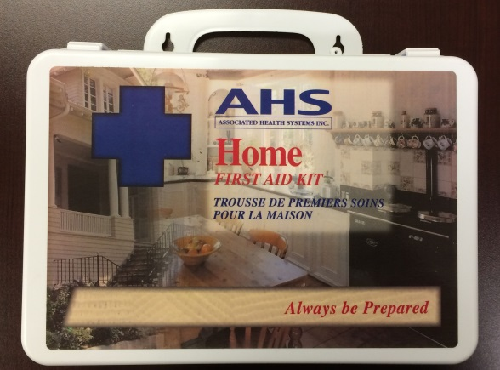
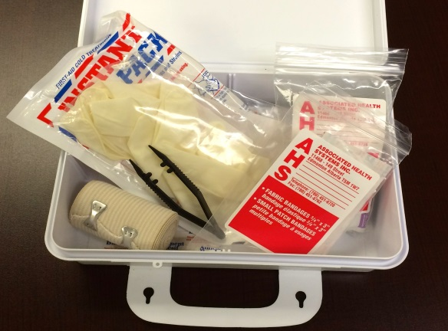

Post self-assessment

I think my skills have improved as a result of completing this activity.
- Yes
- No

Learner comments:
_____________________________________________________________________________
________________________________________________________________________________________________________
________________________________________________________________________________________________________

Assessment
Task-Based Activity: Make a list of items for a first aid kit
Learner Name: _____________________________ Date: ____________________________

Practitioner Name: _______________________________________

Performance Descriptors | Needs Work | Improving | Excellent
B3.1a: Make straightforward entries to complete very simple documents
- makes a direct match between what is requested and what is entered
- makes entries using familiar vocabulary

The learner needs to work on the following:

This task was successfully completed ______ This task needs to be tried again ______

Practitioner Comments:

Learner Comments:

